 |   Defecting customers are far less of a problem than customers who change their buying patterns. New ways of understanding these changes can unlock the power of loyalty.
Stephanie Coyles and Timothy C. Gokey
The McKinsey Quarterly, 2002 Number 2
Companies spend millions trying to understand and influence customers—to hold on to them and to encourage them to spend more. But to increase the customers’ loyalty, companies must do more than track today’s typical metrics: satisfaction and defection. For despite all the money invested to promote loyalty among high-value customers, it is increasingly elusive in almost every industry.
A better appreciation of the underlying forces that influence the loyalty of customers—particularly their attitudes and changing needs—can help companies develop targeted efforts to correct any downward migration in their spending habits long before it leads them to defect. Such an appreciation also helps companies improve their current efforts to encourage other customers to spend more. Our recent two-year study of the attitudes of 1,200 households about companies in 16 industries as diverse as airlines, banking, and consumer products shows that this opportunity is surprisingly large. Improving the management of migration as a whole by focusing not only on defections but also on smaller changes in customer spending can have as much as ten times more value than preventing defections alone. Companies taking the approach we recommend have cut downward migration and defection by as much as 30 percent.
Differentiating and measuring degrees of loyalty is an evolving craft. Companies first tried to measure and manage their customers’ satisfaction in the early 1970s, on the theory that increasing it would help them prosper. In the 1980s, they began to measure their customers’ rates of defection and to investigate its root causes. By measuring the value of the customers themselves, some companies also identified high-value ones and became better at preventing them from defecting. These ideas are still important, but they are not enough. Managing migration—from the satisfied customers who spend more to the downward migrators who spend less—is a crucial next step.
This step is so important because large amounts of value are at stake. Many more customers change their spending behavior than defect, so the former typically account for larger changes in value (Exhibit 1). At one retail bank, for example, 5 percent of checking-account customers defected annually, taking with them 10 percent of the bank’s checking accounts and 3 percent of its total balances. But every year, the 35 percent of customers who reduced their balances significantly cost the bank 24 percent of its total balances, while the 35 percent who increased their balances raised its total balances by 25 percent. This effect showed up in all 16 industries we studied and was dominant in two-thirds of them.
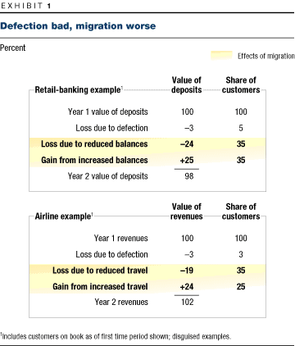
In industries like retailing and credit cards, whose customers generally deal with more than one company, managing migration is vital. But doing so also matters in industries like insurance and telecom services, where a customer might seem to have a single primary provider. One local phone company, for example, found that more than 90 percent of its loyalty opportunities came from reaching out to customers dropping features such as second lines and call waiting.
Managing migration not only gives companies an early chance to stem the downward course before their customers bolt entirely but also helps them influence upward migration earlier. Since the opportunities in either direction are equally good, and many of the tactics companies can use to influence their customers’ spending are the same regardless of which effect they focus on, a company taking aim at either upward or downward migration can double the bang for its buck.
Understanding customers
To influence what customers spend, a company must generally dig deeper than merely finding out whether they like the product or service on offer. A broad measure of satisfaction can tell a company how likely customers are to defect; mobile-phone customers, for instance, continually switch providers because of customer service problems. But satisfaction alone doesn’t tell a company what makes customers loyal: the product or the difficulty of finding a replacement, for example. Nor does gauging satisfaction levels tell a company how susceptible its customers are to changing their spending patterns—variations that more often come about as a result of changes in their lives, in the company’s offer, or in its competitors’ offers. Understanding the other drivers of loyalty, our research showed, is crucial to having an influence on migration.
By learning to understand why customers exhibit different degrees of loyalty, and combining that knowledge with data on current spending patterns, companies can develop loyalty profiles that define and quantify six customer segments (Exhibit 2). Three of them can be viewed as loyalists; that is, they are maintaining or increasing their expenditures. These customers are loyal because they are emotionally attached to their current provider, have rationally chosen it as their best option, or don’t regard switching as worth the trouble. The remaining segments—the downward migrators—have one of three reasons for spending less: their lifestyle has changed (as a result, say, of moving or having babies), so they have developed new needs that the company isn’t meeting; they continually reassess their options and have found a better one; or they are actively dissatisfied, often because of a single bad experience, with a rude salesclerk, for example.
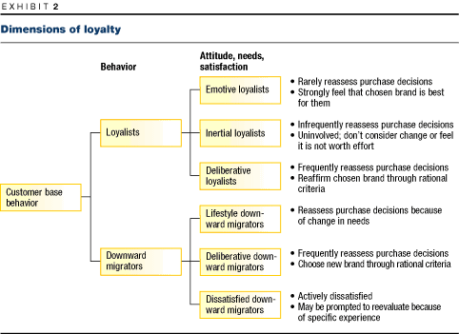
For industries that don’t have many competitors capable of meeting the basic needs of their customers, active dissatisfaction plays the strongest role in downward migration. As the number of competitors providing a minimum level of satisfaction increases, other factors tend to assume a larger role; customers are more likely to compare the merits of various voice mail options, for instance, once phones can be counted on to work reliably.
Three basic customer attitudes—emotive, inertial, and deliberative—underlie loyalty profiles.¹ Emotive customers are the most loyal. Feeling strongly that their current purchases are right for them and that their chosen prod-uct is the best, they rarely reassess purchasing decisions. These feelings can reflect a product’s long record of good performance, but they are often fostered by intangible factors. Soft drinks are a classic example: they are very similar, but nearly half of all people who purchase them have strong favorites. Our research shows that emotive customers generally spend more than those who deliberate over purchases and migrate at a much lower rate. Emotive people are thus, rightly, the marketers’ Holy Grail, and companies will find value in increasing the proportion of their customers in this group.
Inertial customers, like emotive ones, rarely reassess their purchases, but their inaction results from high switching costs or a lack of involvement with products. Utilities and life insurers are good examples of industries whose customers tend to be inertial. Although these customers aren’t prone to spend more or less than they currently do, influencing them offers about as much opportunity as influencing emotive customers, largely by making them less likely to migrate downwardly in response to shocks such as price hikes, isolated cases of bad service, and lifestyle changes.
Deliberators—both those who maintain their spending and those who spend less—are on average the largest group, representing 40 percent of all customers across industries. The rewards from influencing deliberators can be twice as high as the rewards from influencing emotive and inertial customers. Deliberators frequently reassess their purchases by criteria such as a product’s price and performance and the ease of doing business with a company. Emotional appeals won’t trump such objective factors, although these customers’ requirements vary from person to person. Retail gasoline and groceries are the kinds of products that draw a preponderance of deliberative customers. Deliberators who value convenience and quality in a grocery store, for example, would likely choose a nearby grocer with a gourmet deli. A more value-conscious customer might well choose a more distant store offering better prices. Still, both of those customers would constantly reevaluate their decisions by considering the specific purpose of a trip or new information.
Finally, many companies make little effort to meet their customers’ changing needs, which (besides those brought on by moving or having a child) might include new financial or insurance products for aging customers and new travel arrangements made necessary by updated corporate-travel policies. Although changing needs are often dismissed as uncontrollable, our work shows that they can be addressed, especially if a company invests in a new product or channel. Meeting these new needs is a smaller but relevant part of the overall loyalty opportunity.
Profiling customers
Our research also showed that the proportion of people in each loyalty segment differs by industry (Exhibit 3); we found, for example, that far fewer customers are emotionally attached to their grocery stores than to their long-distance providers. For both mobile-phone providers and Internet service providers, however, deliberators predominate, so even among different kinds of telecom companies, the proportions in each segment can vary a lot.
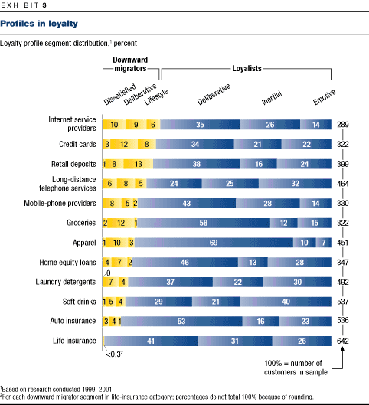
This fact implies that the reasons for migration differ greatly among industries. Deliberative customers, for example, who change their spending patterns because of factors like convenience, account for more than 70 percent of reduced spending by purchasers of casual apparel but only one-third of reduced spending by mobile-phone customers. These differences show why reward programs appealing to deliberators, for instance, might be highly successful in one industry but not another.
Although loyalty profiles vary from company to company, each industry has an average behavior pattern that influences the customers’ loyalty. These patterns are generally determined by five structural factors: how often purchases are made; the frequency of other kinds of interactions, such as service calls; the emotional or financial importance of a purchase; the degree of differentiation among competitors’ offerings; and ease of switching.
Using loyalty profiles
Armed with its loyalty profile, a company gains new insights. First, the profile reinforces the point that building loyalty isn’t just, as the traditional view would have it, about preventing defections and encouraging extra spending; it is about understanding and managing all six loyalty segments. Second, the profile highlights the different tactics required to manage each of the segments and a company’s need to carry out a range of actions to reach all of them; a single act rarely increases the loyalty of all customers. Third, when combined with standard customer-value analysis, the profile helps a company base its loyalty-building priorities on the size of each opportunity.
One financial institution, for example, aimed all its loyalty efforts at increasing its customers’ satisfaction. It did so measurably, made major investments to cut down on service failures (such as unanswered phones), and reduced the number of closed accounts. But the effect on overall growth was marginal, and the company’s loyalty profile shows why: customers are spending less of their money at such financial institutions mainly because their needs are changing—for example, they might be sending their children to college. Deliberative behavior, based on factors like prices and features, ran a close second. Here, as in most industries we studied, downward migration due to dissatisfaction represents a small proportion of the total loyalty opportunity.
To create a balanced program that addresses these issues, many companies will wish to start by trying to influence deliberators, since they make up some 40 percent of the overall opportunity. Deliberators are particularly important for industries in which brands are relatively indistinct, compari-sons are easy to make, and competitors differentiate primarily on such functional attributes as price.
Because deliberators tend to be hardheaded, and the range of attributes they value is wide, it isn’t always easy to influence them. To take the first step toward understanding what customers value, companies can use their existing market research to determine the importance to their deliberators of attributes such as functional benefits (how well the product works compared with alternatives to it, for example, and whether it is worth the price), process benefits (which improve the way the customer receives it), and relationship benefits (such as being a "preferred" customer, who gets special discounts or services).
Once a company understands the elements that its customers value, it must take the basic step of fixing any weaknesses (such as uncompetitive prices) in its offer. Beyond such broad changes, companies can create superior value propositions by tailoring other benefits to specific subsegments; if it is too expensive to increase benefits to all of them, for example, a company can first target its most valuable customers. This approach not only reduces the chance they will defect but also encourages them to consolidate their spending in order to go on receiving benefits, thus encouraging upward migration.
One approach that sophisticated marketers take is to expand the deliberators’ concerns from, say, price alone to include other factors. Well-structured reward programs often provide the kinds of concrete process or relationship benefits that appeal to many deliberators. Hertz, for example, centrally stores all customer and payment data for the members of its #1 Club Gold program, so that customers don’t have to fill out repetitive forms every time they rent cars. In this way, Hertz encourages frequent travelers to base their decisions about which car rental company to patronize not only on price but also on the ability to save time.
Of course, benefits are worthless if deliberators don’t know about them. Communicating benefits well, we found, can often have the greatest impact, because customers often don’t know about offers they could take up or, worse yet, about benefits they already receive. Systematic communication with target customers likely to benefit from specific offers is the heart of successful customer relationship management and can be highly effective in influencing deliberators, who are constantly reassessing their options.
Many process benefits that appeal to deliberators help influence inertial customers too. The point is to make it so easy for them to use the product that they don’t think about it and, if they do, to make switching seem more inconvenient. Characteristic tactics include automating key interactions, such as bill payments and subscription renewals; storing information needed repeatedly (for instance, addresses or credit card numbers) as many on-line stores do; ensuring that a company’s products work better together than any of them works with products from competitors (by integrating account statements, for example); and offering bundled services (such as a mobile-phone and pager package).
Deliberative and inertial customers represent, on average, more than half the total. But to influence the full range of customers, a company must also continue its familiar efforts to increase their satisfaction and to build emotional ties with them, as well as meet their changing needs when possible. In all of these cases, a company’s loyalty profile helps it target its spending more effectively.
Although emotionally loyal customers often constitute a relatively small segment, building emotional ties should be a long-term goal for most companies. Emotionally loyal customers are crucial, for given their higher spending and lower rate of downward migration, they are the most valuable of all. Our research and client work have shown that even in industries with few emotive customers, such ties can be developed over time. The loyalty profile helps a company determine the extent of this opportunity—and thus the amount of money that should be invested in it.
The primary tools for building emotional ties are a coordinated set of actions, including brand communication and delivery, to highlight what is unique about the product. This approach can be implemented broadly, to all customers, or more narrowly, to specific customer segments or affinity groups. The financial-products company USAA, for example, has highly loyal customers as a result of the shared affinity that comes from limiting its membership to US military officers and their dependents.²
A company with many customers whose needs are changing might find it worthwhile to see if it can meet them. Companies can use their market surveys and demographic data to distinguish the changes they can’t address, such as new corporate-travel policies that force customers to cut spending, from those they can, such as the need of aging customers for new financial products. Sometimes, as with efforts to influence deliberators, such needs can be met through better communication about existing products or coordination among different parts of the company—as happens, for example, when financial-services providers that administer corporate pension plans capture "rollovers" when employees leave their companies and take their pension money with them. At times, however, a company must develop new products: Honda, for instance, created a minivan because loyal customers starting families wanted larger vehicles. On occasion, the moves required to meet changing needs go even further: Charles Schwab is working to increase its customers’ loyalty by providing investment-planning services and acquiring the full-service bank U.S. Trust, thus increasing the chances that Schwab will have the products that customers want as they become more affluent.
Finally, dealing with even small pockets of dissatisfaction is a necessary part of creating an organizational culture attuned to pleasing customers. Avoiding and addressing service failures, for example, is obviously important; customers who have had them resolved satisfactorily are typically just as loyal, and sometimes more so, than customers who have never had them at all. A company can use its loyalty profile to see how many dissatisfied customers it has and thus how much of its overall loyalty-building budget it should devote to meeting their needs. For some companies, addressing dissatisfaction will be crucial; customer service problems cause half of the downward migration at mobile-phone companies, for example. A much lower percentage is more common, however, and many companies will decide to invest strategically—perhaps only to reach the most valuable customers.

By using a coordinated approach to understanding the many facets of loyalty and by tailoring tactics appropriately, several companies have reduced downward migration and defection by 20 to 30 percent. Consider the case of the retail bank that saw 50 percent of its annual balances in play because of migration. Even assuming that more than half of the change was due to factors the bank couldn’t influence, and even if it managed to recapture only 20 percent of the rest, its top-line growth, currently in single digits, would rise by three to five points. Similarly, department stores using a coordinated approach have cut downward migration by 25 to 30 percent, leading to top-line gains comparable to a 1 to 2 percent increase in same-store sales, a key retailing metric generally in single digits. For banks and the many other industries with modest price-to-earnings ratios, increasing growth rates by the clearly feasible target of 3 percent should lead, within three years, to a 25 percent increase in market capitalization.
By focusing on migration and by understanding the motives that underlie customer loyalty, companies can increase that loyalty in a meaningful way.
Notes:
Stephanie Coyles is a principal in McKinsey’s Toronto office, and Tim Gokey is a principal in the Minneapolis office.
¹A few industries, such as fashion and packaged goods, have a fourth kind of customer, who primarily seeks variety.
²For more on building emotional ties, see David C. Court, Mark G. Leiter, and Mark A. Loch, "Brand leverage," The McKinsey Quarterly, 1999 Number 2, pp. 100–10; Nicky Buss, Blair Crawford, Jonathan Gordon, and Ian St-Maurice, "Unlock your brand," McKinsey Marketing Solutions, January 2001; and "The power of brand building," McKinsey Marketing Solutions, July 2001.

